Open Curved Shapes
# Source: AI Source: Provided by: [Data Path: Persons Table -> ID Column: 1, Name_En Column: Motasem Essam] -> From: [ChatGPT] on [7/25/2026]
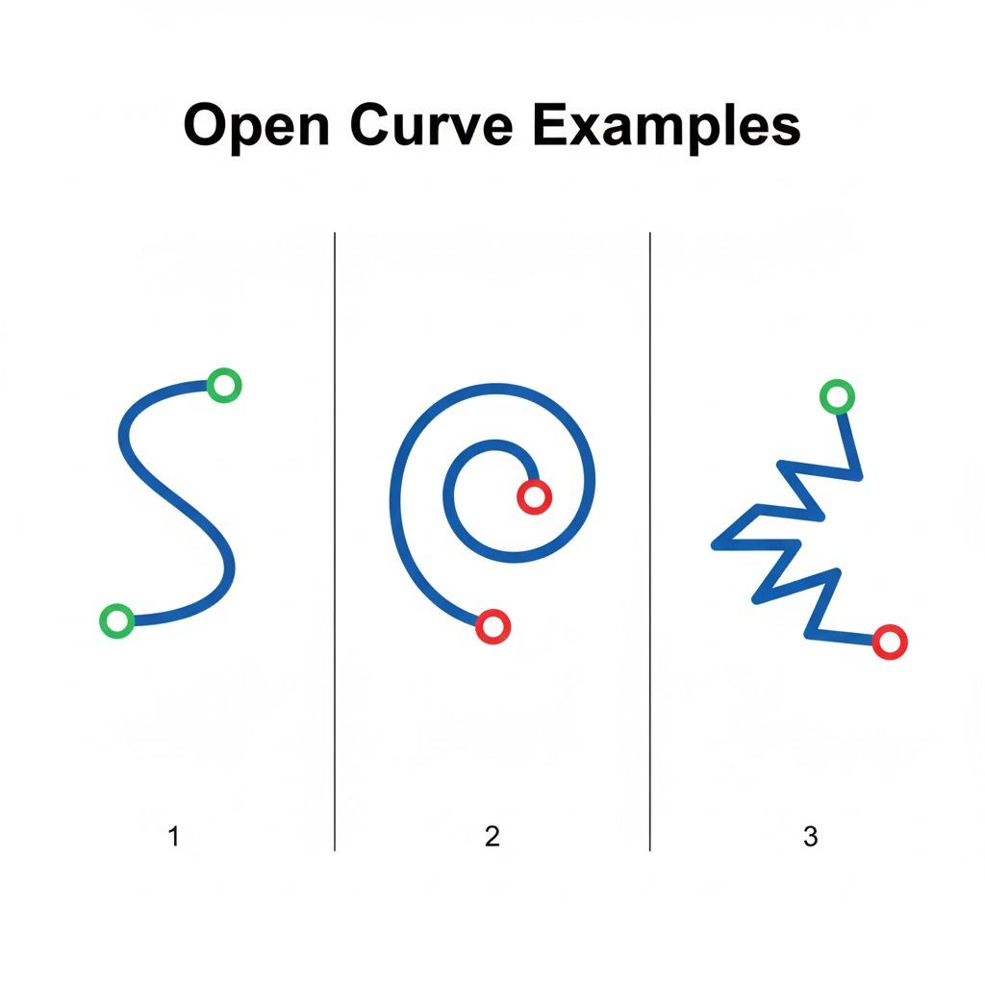
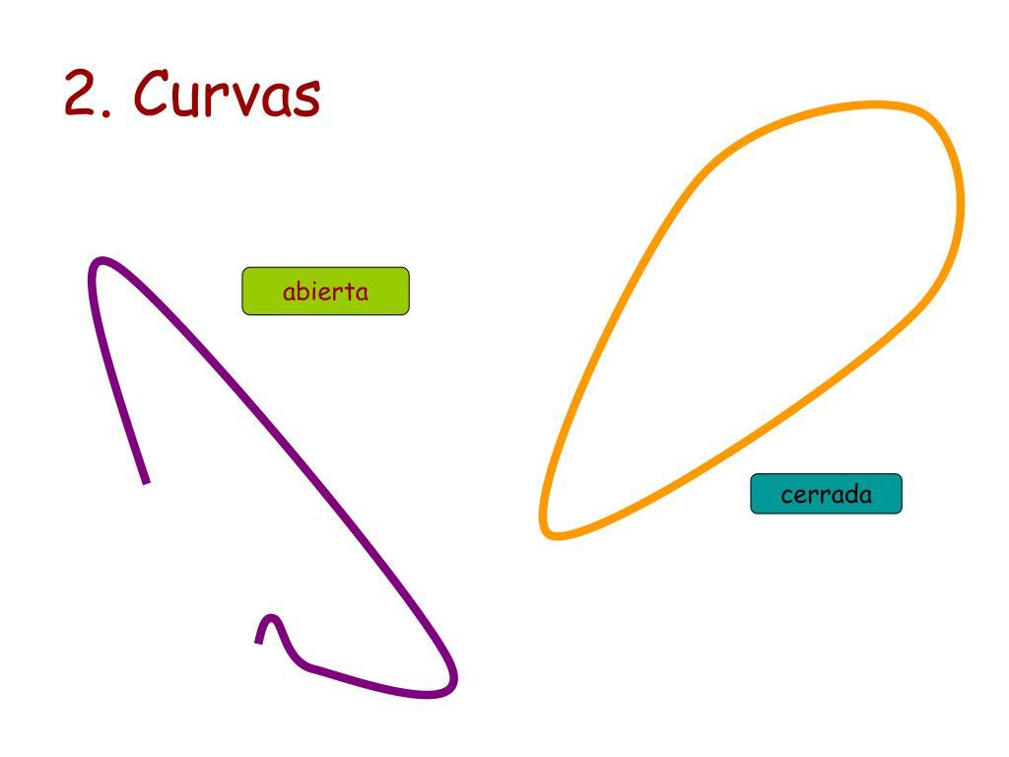
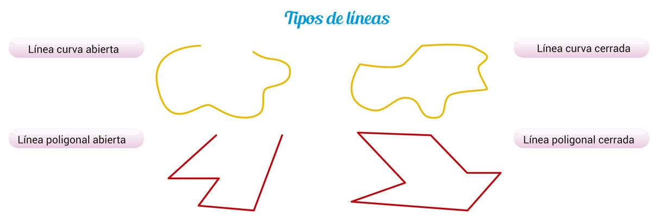
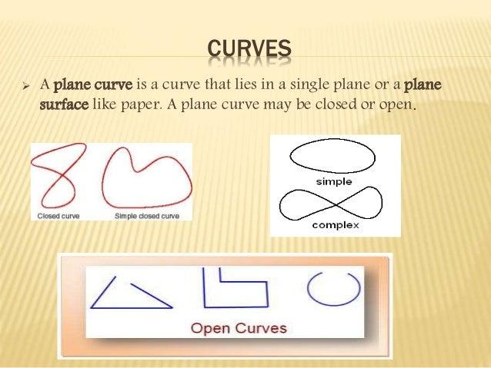

Definition
# Source: AI Source: Provided by: [Data Path: Persons Table -> ID Column: 1, Name_En Column: Motasem Essam] -> From: [ChatGPT] on [7/25/2026]
An Open Curved Shape is an open plane figure whose boundary or path consists of one or more curved portions and whose endpoints do not connect to form a closed boundary.
In simple terms:
It is a curved path that does not return to its starting point.
$$\boxed{\text{Open Curved Shape}=\text{Open}+\text{Curved}+\text{Unconnected Endpoints}}$$
For mathematical precision, open curved shape is often better described as an open curve.

Characteristics
# Source: AI Source: Provided by: [Data Path: Persons Table -> ID Column: 1, Name_En Column: Motasem Essam] -> From: [ChatGPT] on [7/25/2026]
An open curved shape typically:
- Is open.
- Has two distinct endpoints.
- Contains curved geometry.
- Does not enclose a bounded region by itself.
- Has no closed boundary.
- May have constant or variable curvature.
- May be regular or irregular.
- May be symmetric or asymmetric.
- Can be represented using equations, parametric curves, or freeform curves.
The defining condition is:
$$\boxed{P_{\text{start}}≠P_{\text{end}}}$$

Types of Open Curved Shapes

1. Open Circular Arcs
# Source: AI Source: Provided by: [Data Path: Persons Table -> ID Column: 1, Name_En Column: Motasem Essam] -> From: [ChatGPT] on [7/25/2026]
An open circular arc is a portion of a circle that does not complete the entire circle.
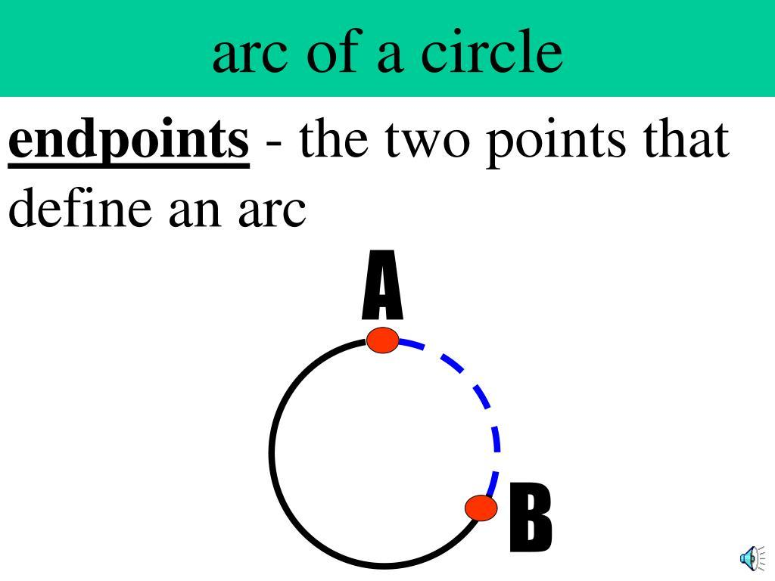
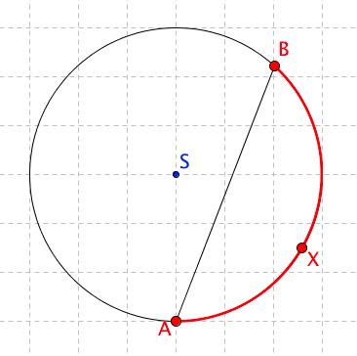
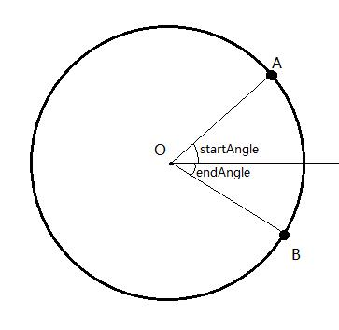
A circle satisfies:
$${\left(x-h\right)}^{2}+{\left(y-k\right)}^{2}=r^{2}$$
while an arc represents only part of that circular boundary.
Examples include:
- Minor arc
- Major arc
- Semicircular arc
- Quarter-circle arc

2. Open Elliptical Curves
# Source: AI Source: Provided by: [Data Path: Persons Table -> ID Column: 1, Name_En Column: Motasem Essam] -> From: [ChatGPT] on [7/25/2026]
An open elliptical curve is a portion of an ellipse rather than the complete closed ellipse.
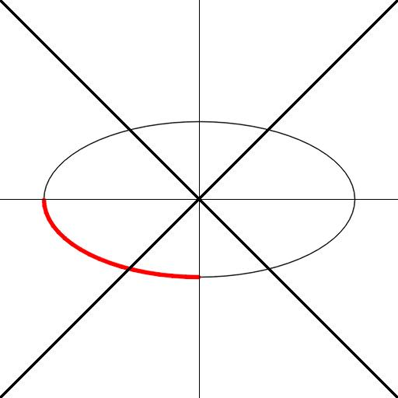
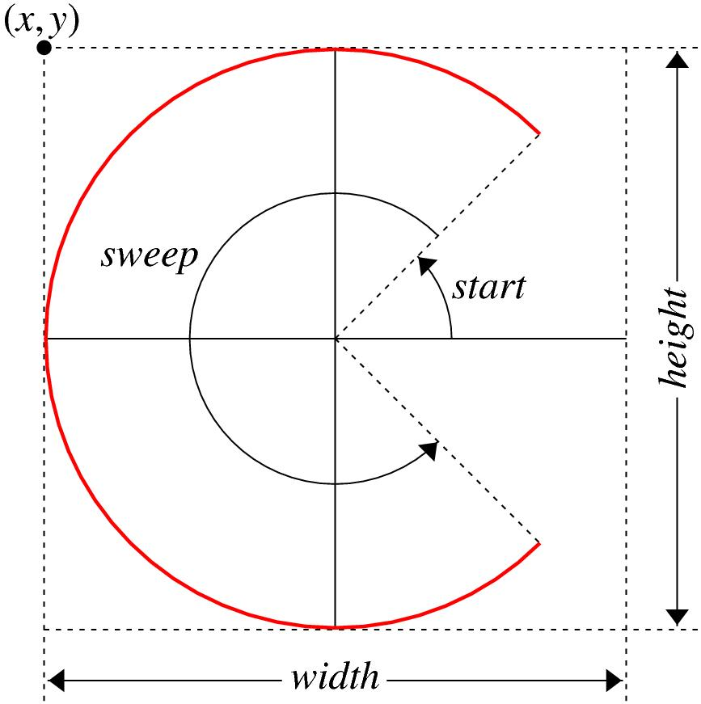
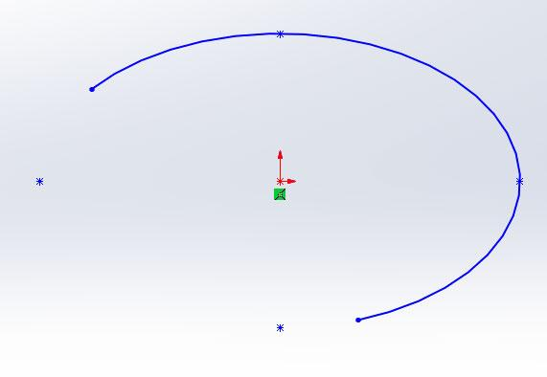
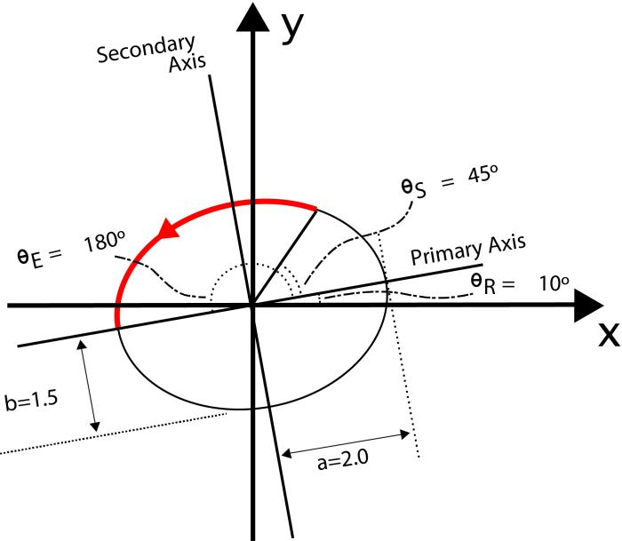
The complete ellipse is closed, but a portion of it forms an open curved path.

3. Parabolic Open Curves
# Source: AI Source: Provided by: [Data Path: Persons Table -> ID Column: 1, Name_En Column: Motasem Essam] -> From: [ChatGPT] on [7/25/2026]
A parabola is naturally an open curve extending indefinitely.
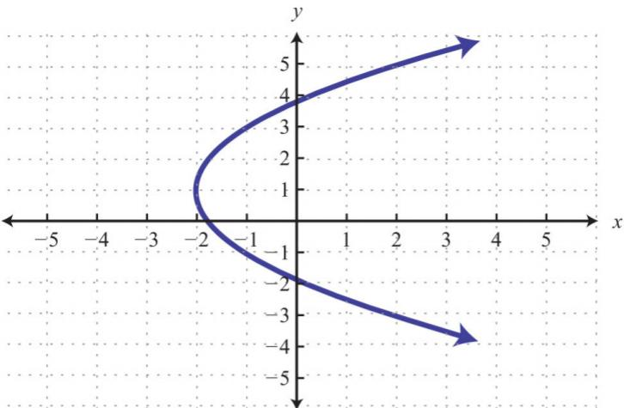
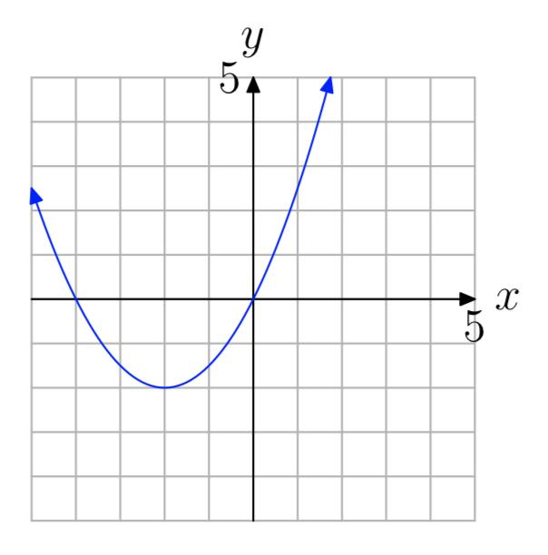
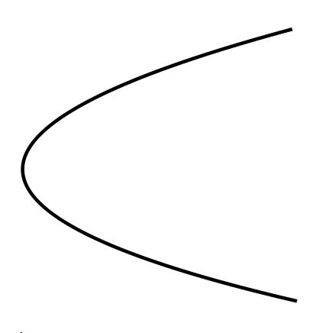
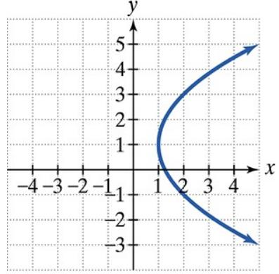
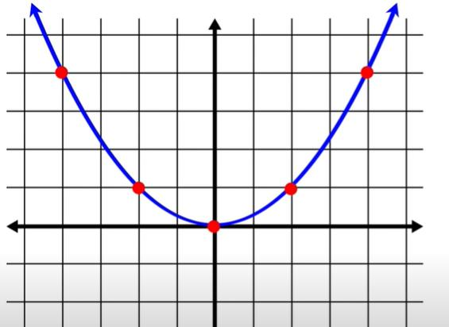
A standard parabola can be represented as:
$$\boxed{y=ax^{2}+bx+c}$$
Unlike a circle or ellipse, a complete parabola does not close.

4. Hyperbolic Open Curves
# Source: AI Source: Provided by: [Data Path: Persons Table -> ID Column: 1, Name_En Column: Motasem Essam] -> From: [ChatGPT] on [7/25/2026]
A hyperbola consists of open branches that extend indefinitely.
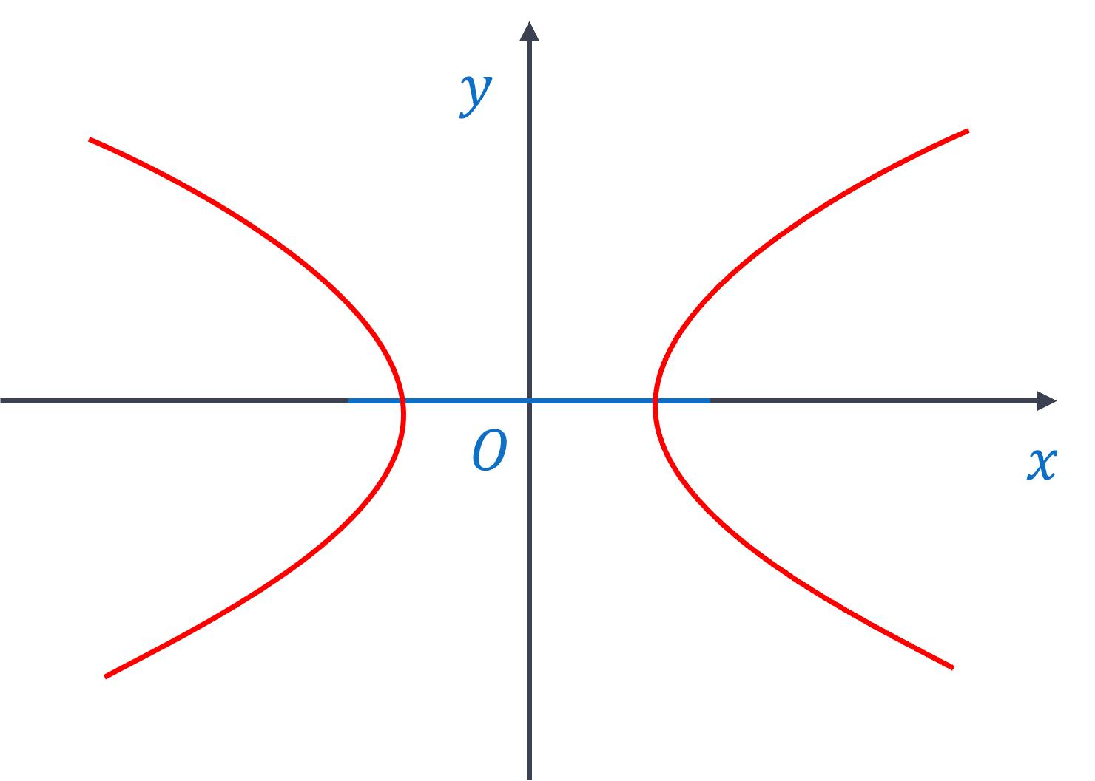
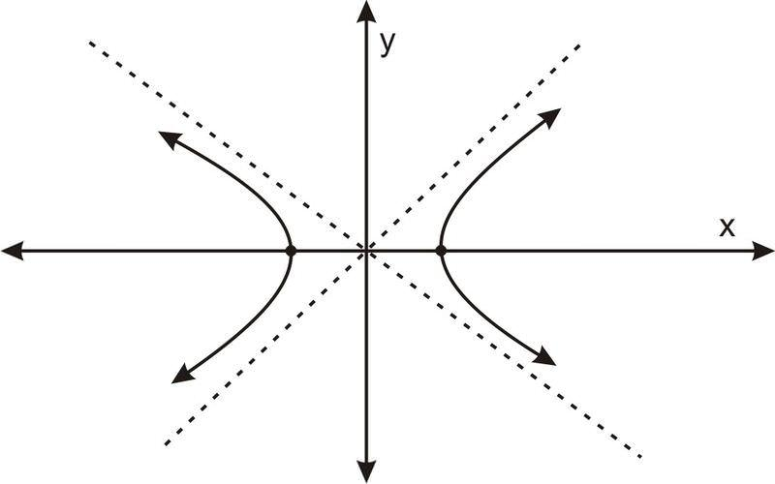
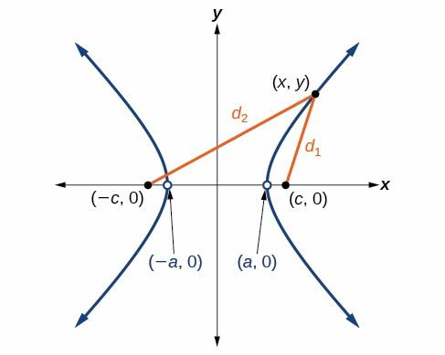
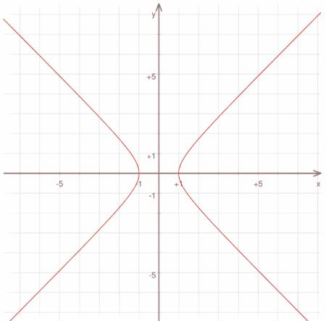
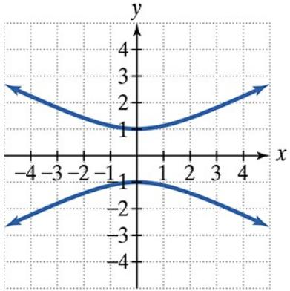
A standard hyperbola may be represented as:
$$\boxed{\frac{x^{2}}{a^{2}}-\frac{y^{2}}{b^{2}}=1}$$
It has separate open branches rather than a closed boundary.

5. Wavy Open Curves
# Source: AI Source: Provided by: [Data Path: Persons Table -> ID Column: 1, Name_En Column: Motasem Essam] -> From: [ChatGPT] on [7/25/2026]
A wavy open curve contains repeated or irregular undulations while remaining open.
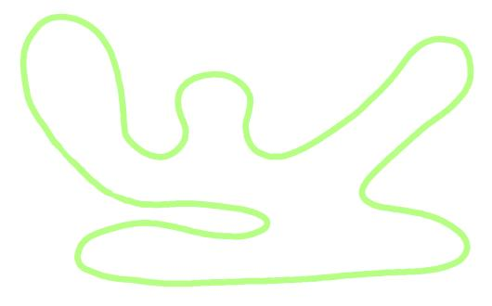
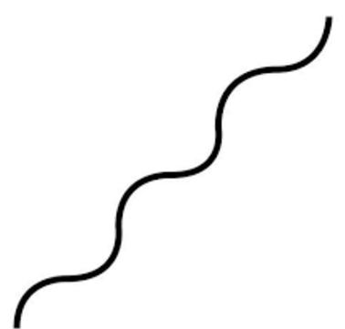
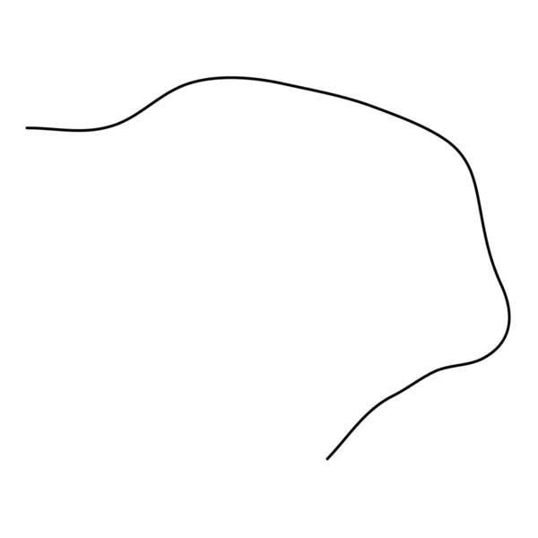
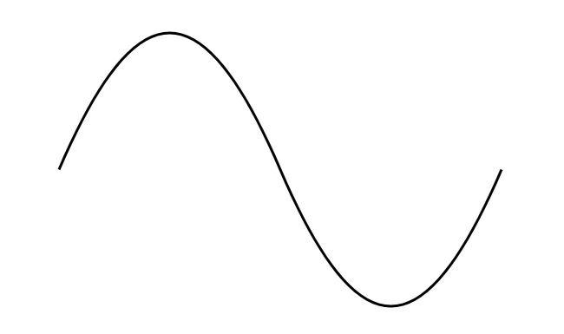
Characteristics may include:
- Repeated waves.
- Variable amplitude.
- Variable wavelength.
- Irregular curvature.

6. Spiral-Like Open Curves
# Source: AI Source: Provided by: [Data Path: Persons Table -> ID Column: 1, Name_En Column: Motasem Essam] -> From: [ChatGPT] on [7/25/2026]
A spiral-like open curve winds around a central area without returning to its starting point.
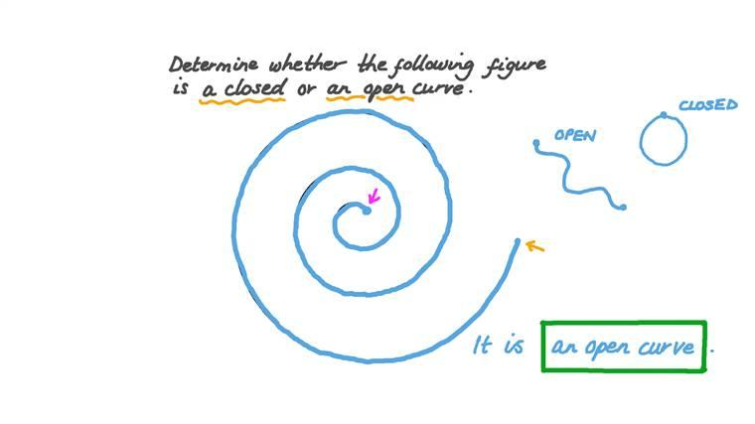
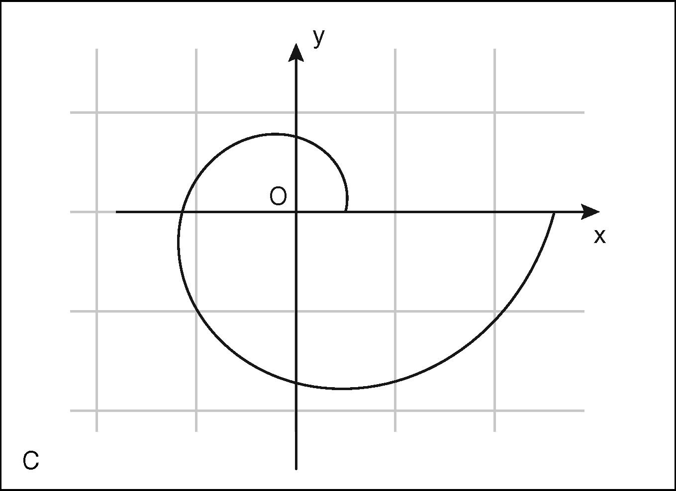
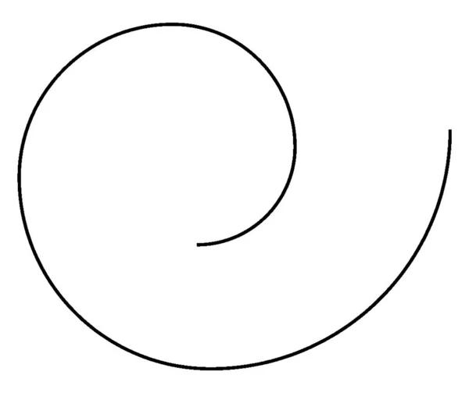
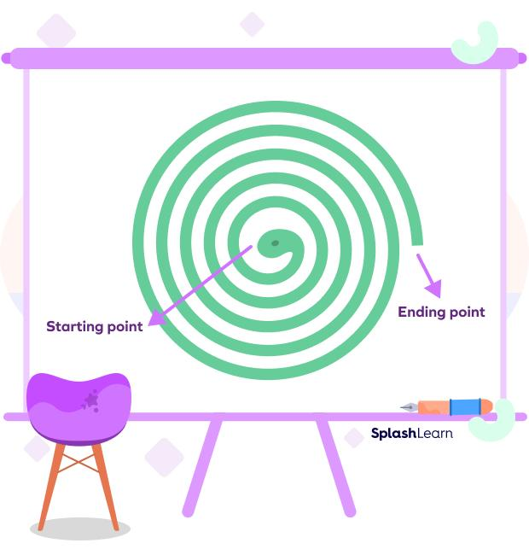
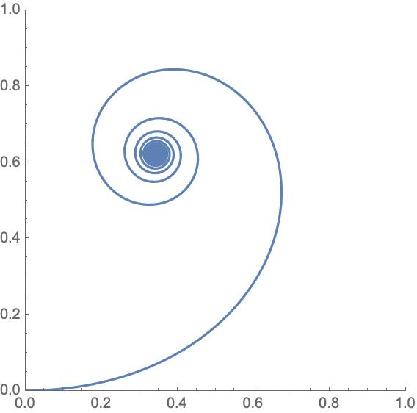
A mathematical spiral may be represented using:
$$r=f\left(θ\right)$$
An irregular spiral-like curve does not need to follow a perfectly regular spiral equation.

7. Organic Open Curves
# Source: AI Source: Provided by: [Data Path: Persons Table -> ID Column: 1, Name_En Column: Motasem Essam] -> From: [ChatGPT] on [7/25/2026]
An organic open curve has a smooth, natural-looking form without necessarily following a standard geometric equation.
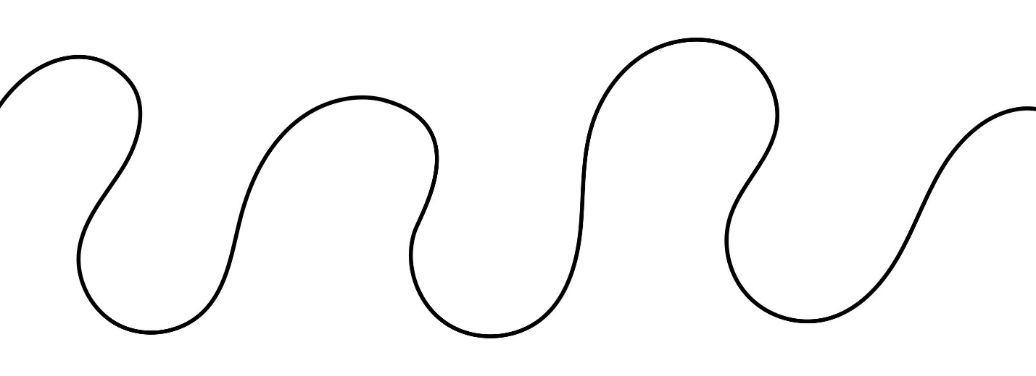
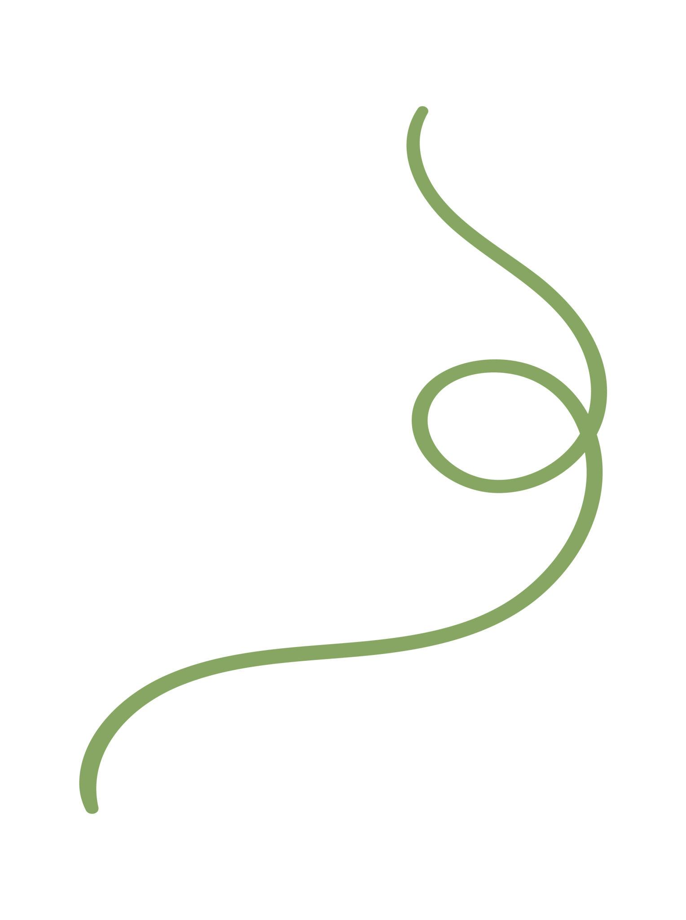
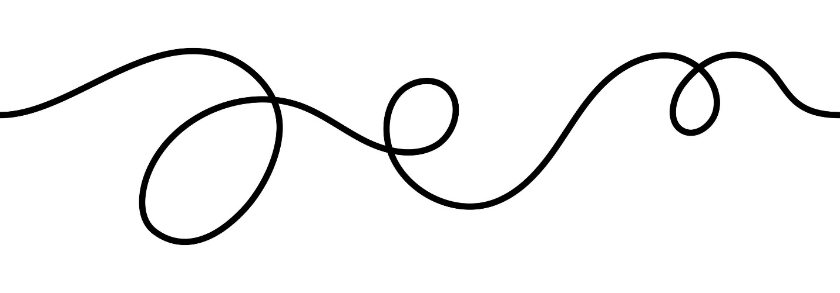
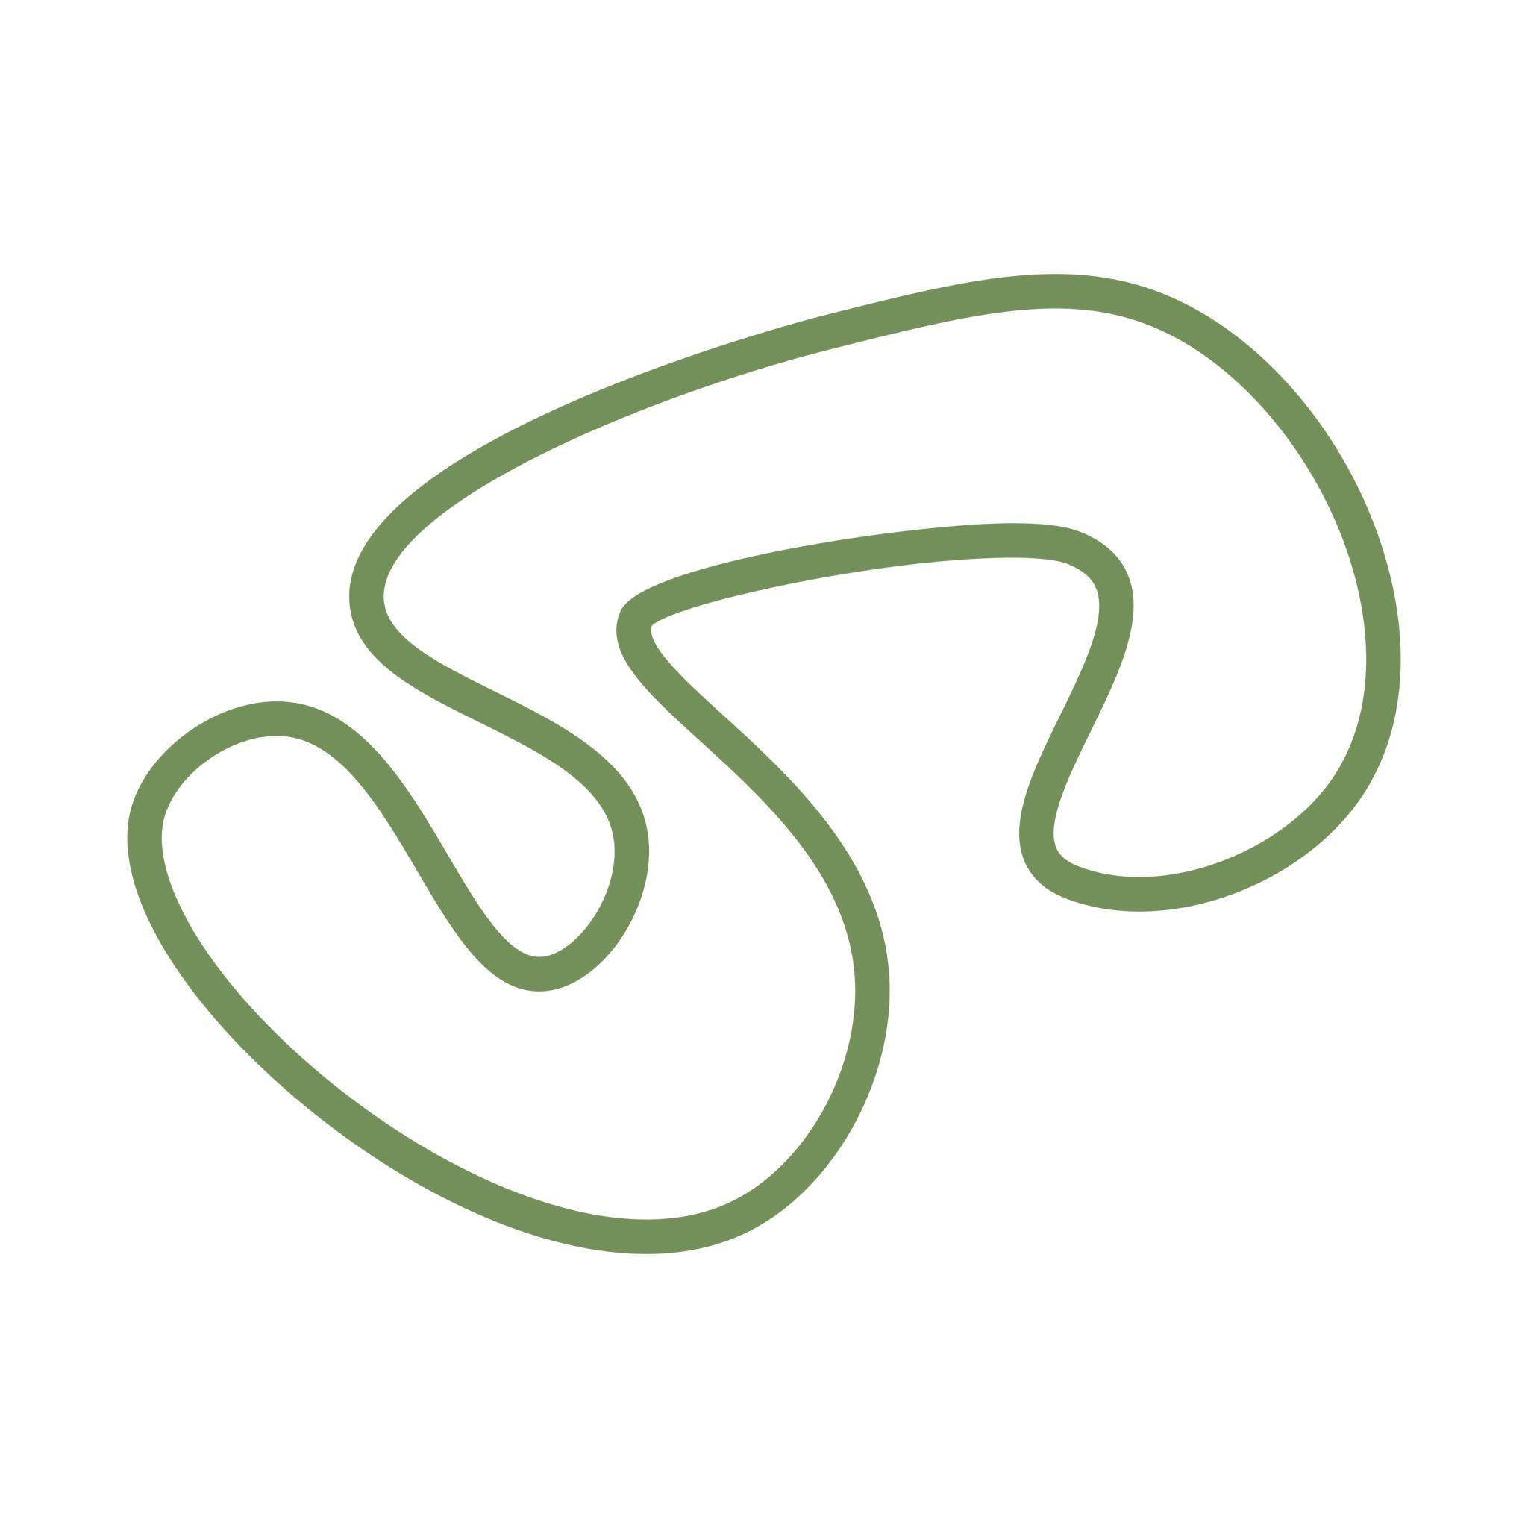
Examples include portions of:
- Branches
- Vines
- Coastlines
- Natural contours
- Biological forms

8. Freeform Open Curves
# Source: AI Source: Provided by: [Data Path: Persons Table -> ID Column: 1, Name_En Column: Motasem Essam] -> From: [ChatGPT] on [7/25/2026]
A freeform open curve is an artificially designed curve whose shape and curvature are freely controlled.
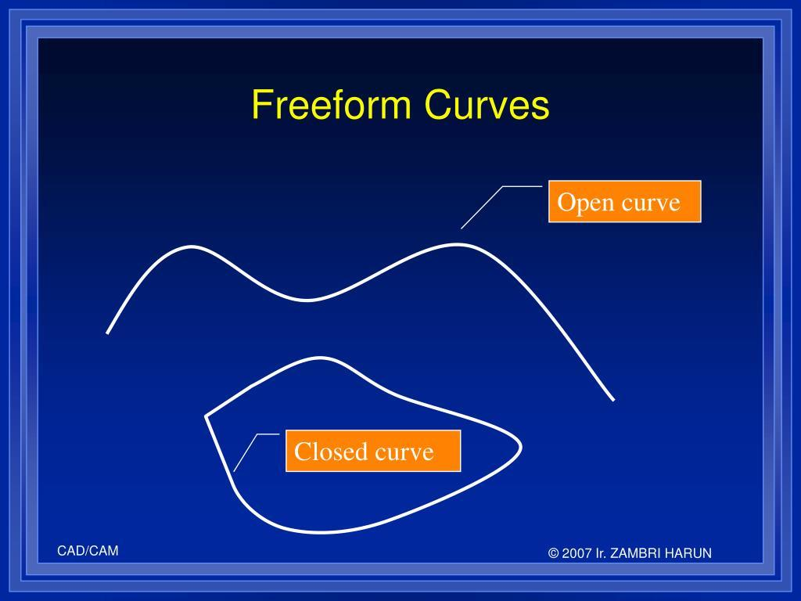
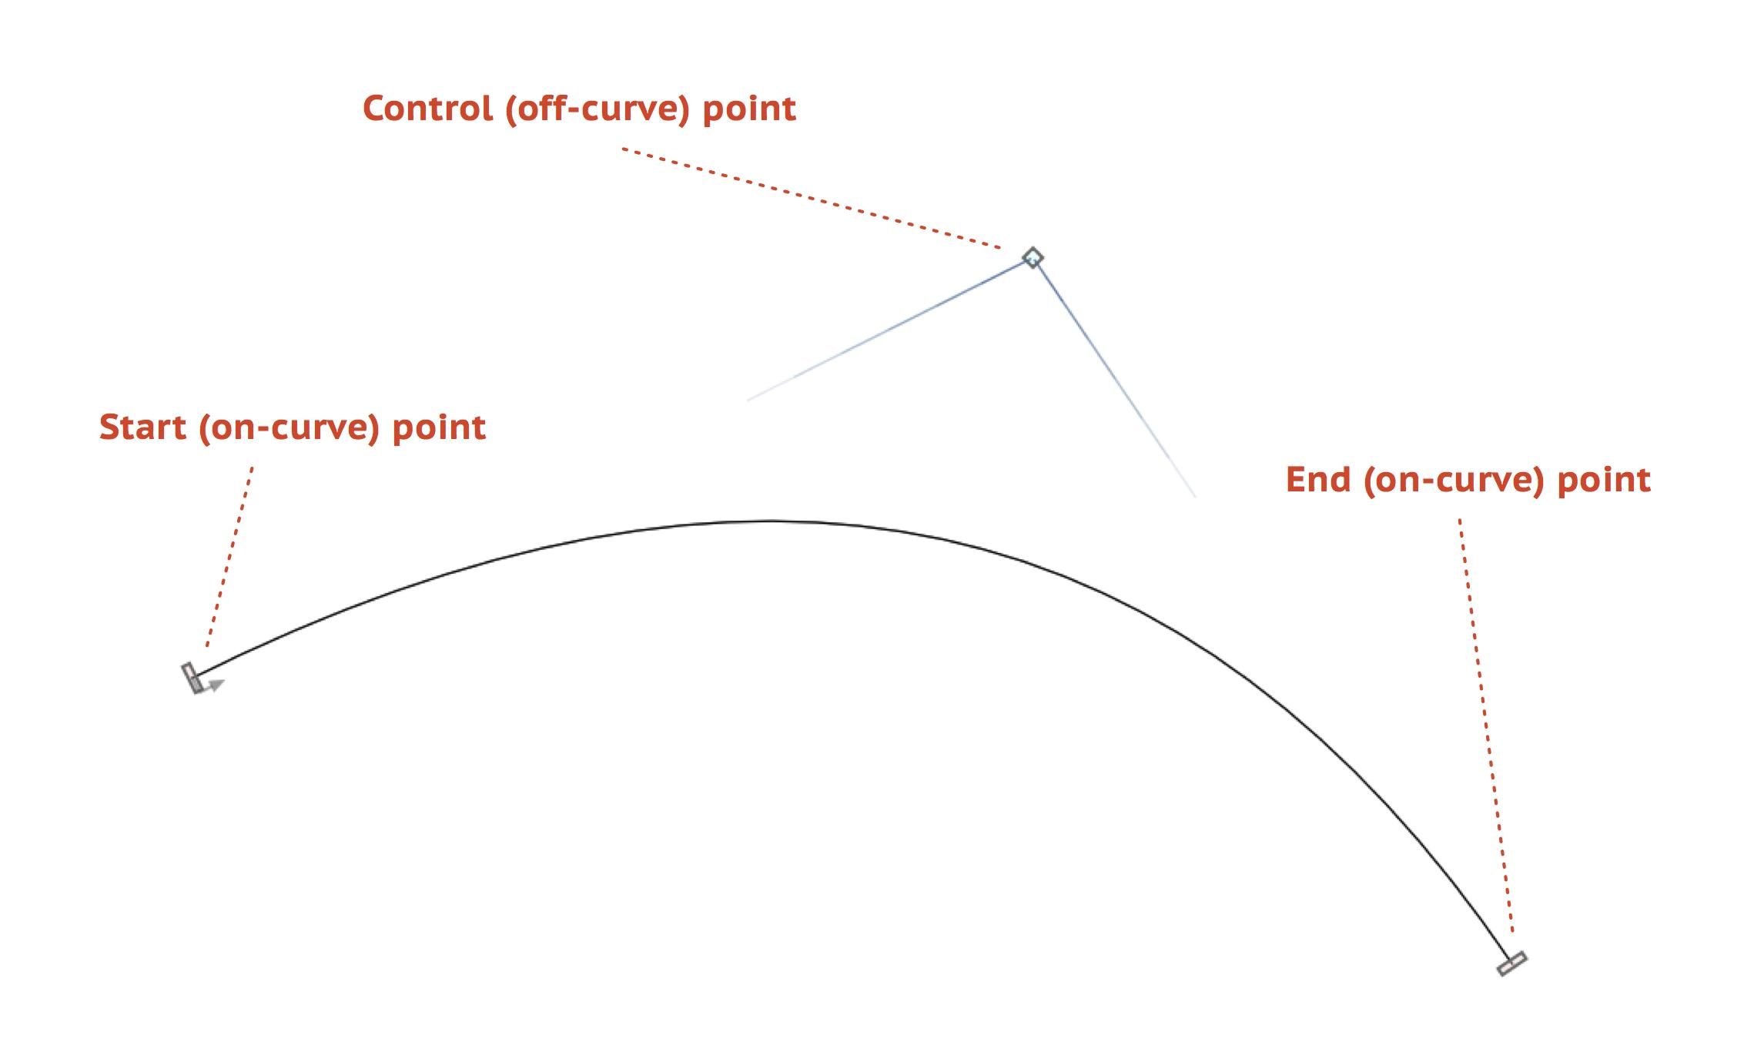
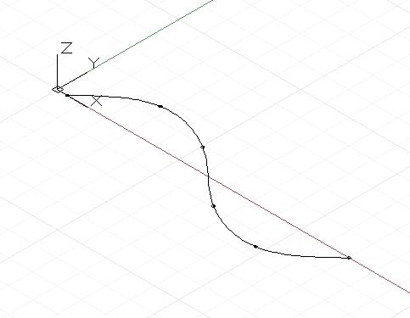
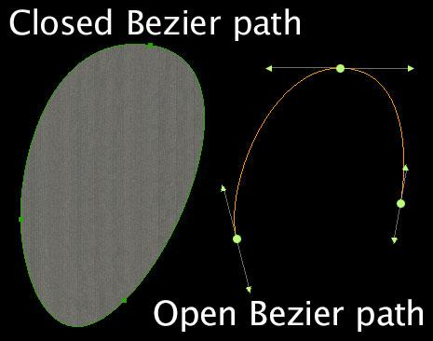
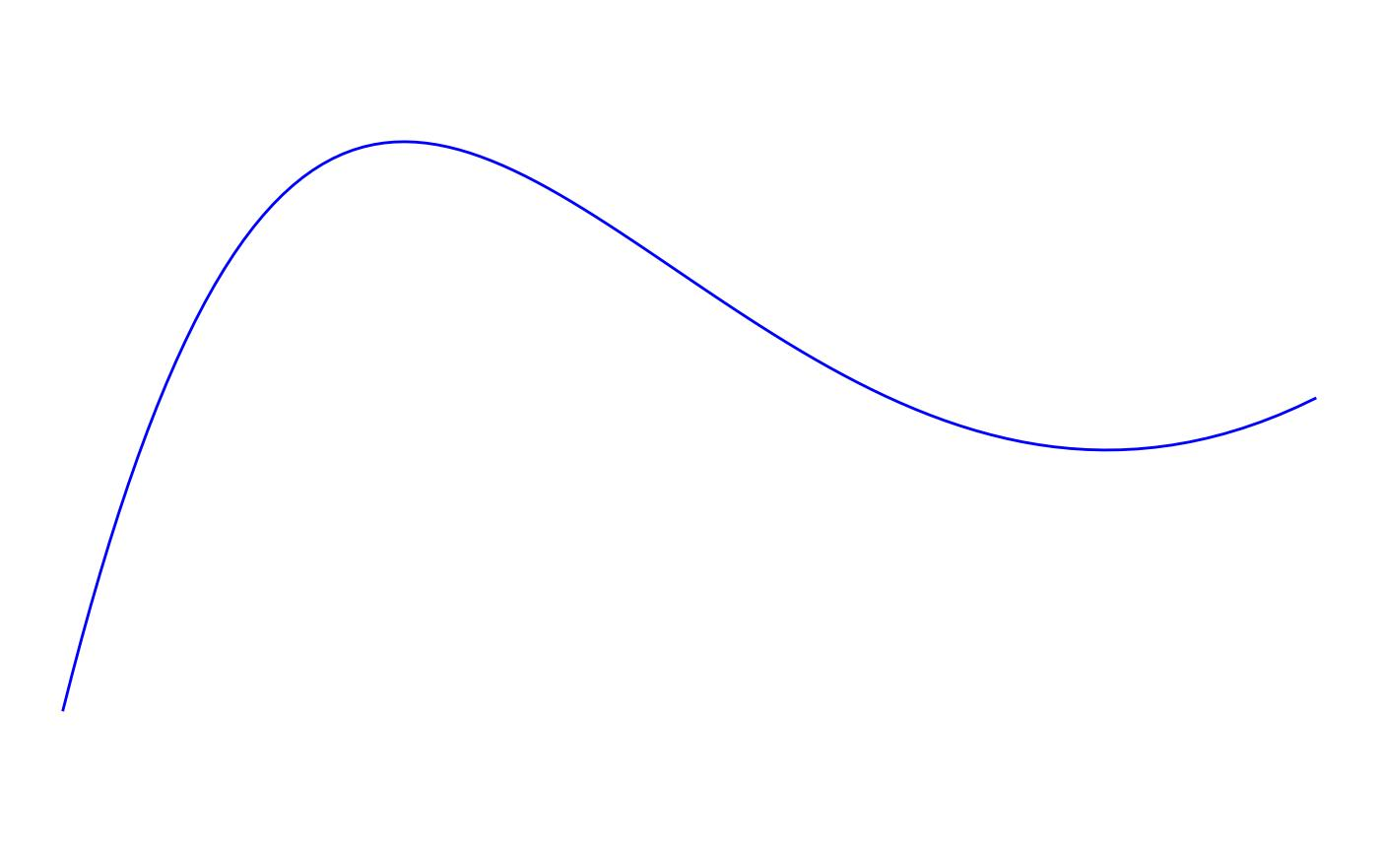
These are common in:
- CAD
- Graphic design
- Vector graphics
- Product design
- Computer graphics

Open Curved vs. Open Polygonal Shapes
# Source: AI Source: Provided by: [Data Path: Persons Table -> ID Column: 1, Name_En Column: Motasem Essam] -> From: [ChatGPT] on [7/25/2026]
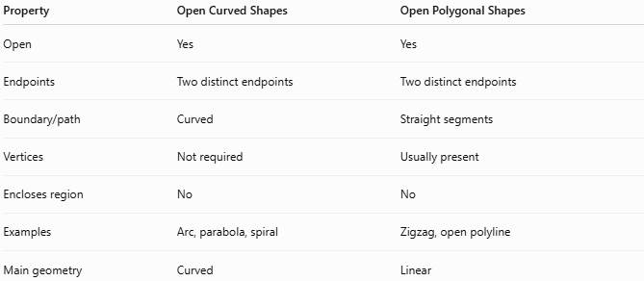
Property | Open Curved Shapes | Open Polygonal Shapes
Open | Yes | Yes
Endpoints | Two distinct endpoints | Two distinct endpoints
Boundary/path | Curved | Straight segments
Vertices | Not required | Usually present
Encloses region | No | No
Examples | Arc, parabola, spiral | Zigzag, open polyline
Main geometry | Curved | Linear
The fundamental distinction is:
$$\boxed{\text{Open Polygonal}=\text{Straight Segments}}$$
while:
$$\boxed{\text{Open Curved}=\text{Curved Segments}}$$

Open Curved vs. Closed Curved Shapes
# Source: AI Source: Provided by: [Data Path: Persons Table -> ID Column: 1, Name_En Column: Motasem Essam] -> From: [ChatGPT] on [7/25/2026]
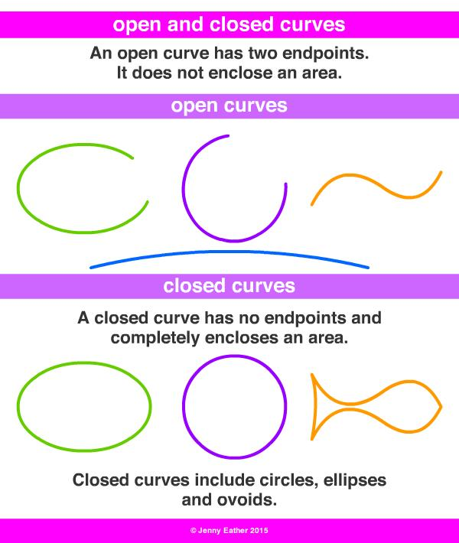
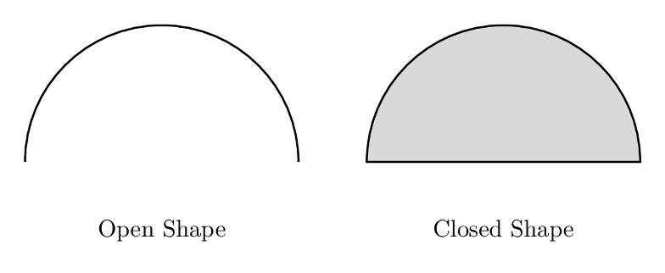
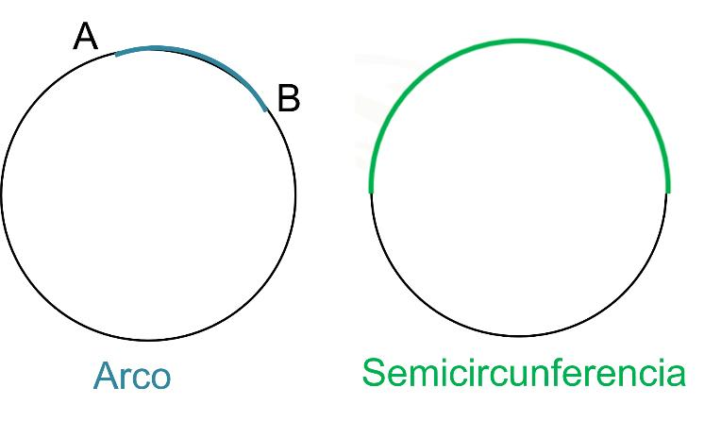
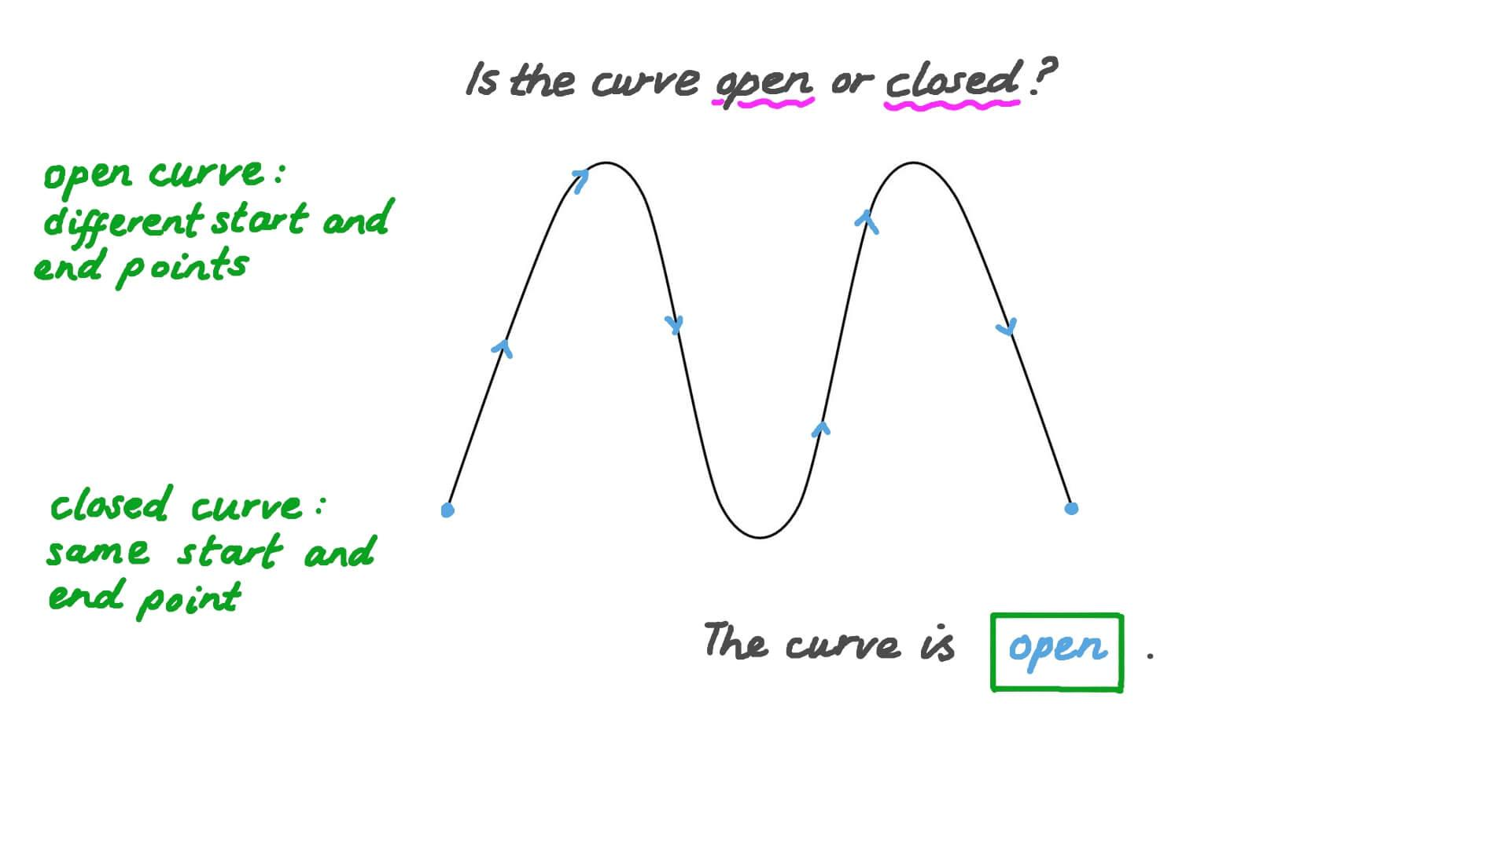
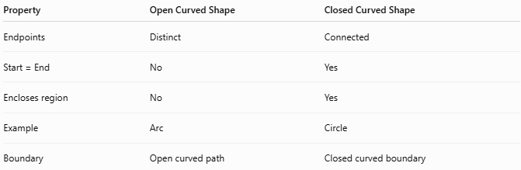
Property | Open Curved Shape | Closed Curved Shape
Endpoints | Distinct | Connected
Start = End | No | Yes
Encloses region | No | Yes
Example | Arc | Circle
Boundary | Open curved path | Closed curved boundary
Mathematically:
$$\boxed{P_{\text{start}}≠P_{\text{end}} \text{Open}}$$
$$\boxed{P_{\text{start}}=P_{\text{end}} \text{Closed}}$$

Length
# Source: AI Source: Provided by: [Data Path: Persons Table -> ID Column: 1, Name_En Column: Motasem Essam] -> From: [ChatGPT] on [7/25/2026]
An open curved shape has a measurable arc length.
For a parametric curve:
$$x=x\left(t\right), y=y\left(t\right)$$
the length is:
$$\boxed{L=\int_{a}^{b}{\sqrt{{\left(\frac{dx}{dt}\right)}^{2}+{\left(\frac{dy}{dt}\right)}^{2}}}dt}$$
For a circular arc:
$$\boxed{L=rθ}$$
where $θ$ is measured in radians.

Area
# Source: AI Source: Provided by: [Data Path: Persons Table -> ID Column: 1, Name_En Column: Motasem Essam] -> From: [ChatGPT] on [7/25/2026]
An open curve does not enclose an area by itself.
$$\boxed{A_{\text{enclosed}}=\text{not defined}}$$
However, if an open curve is combined with other boundaries to form a closed region, that resulting region can have an area.
For example:
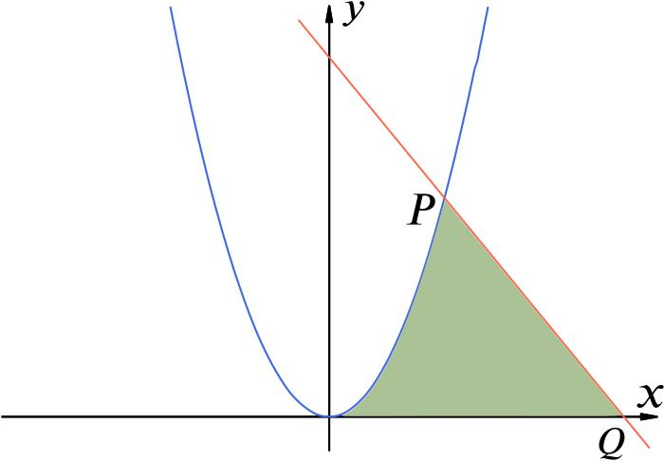
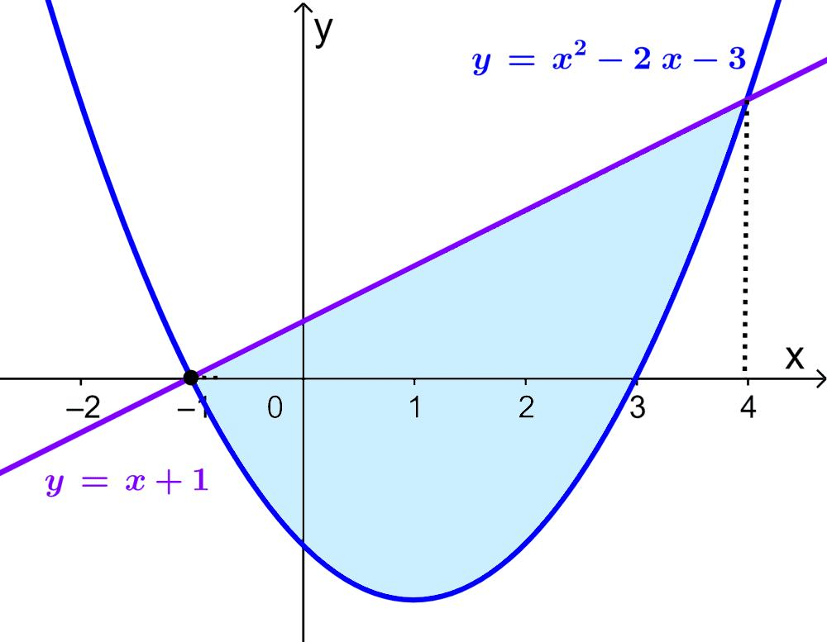
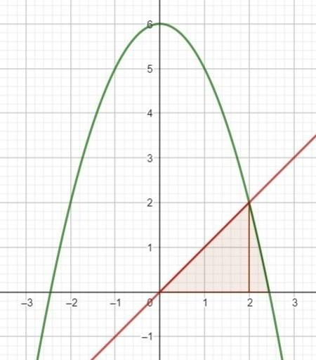
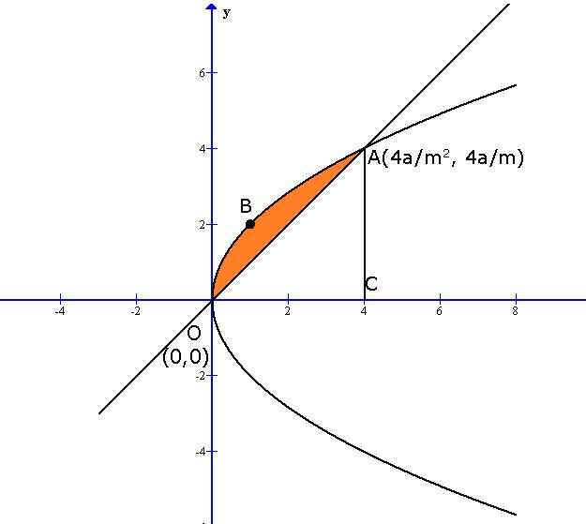
A parabola together with a line segment can form a closed region whose area can be calculated.

Key Points
# Source: AI Source: Provided by: [Data Path: Persons Table -> ID Column: 1, Name_En Column: Motasem Essam] -> From: [ChatGPT] on [7/25/2026]
An Open Curved Shape is:
$$\boxed{\text{Open}+\text{Curved}+\text{Distinct Endpoints}}$$
It:
- Has two distinct endpoints.
- Contains curved geometry.
- Does not form a closed boundary.
- Does not enclose a region by itself.
- Can be regular or irregular.
- Can be mathematical or freeform.
- Can be symmetric or asymmetric.
- Has a measurable arc length.

Conclusion
# Source: AI Source: Provided by: [Data Path: Persons Table -> ID Column: 1, Name_En Column: Motasem Essam] -> From: [ChatGPT] on [7/25/2026]
Open Curved Shapes are open curves whose endpoints remain separate and whose geometry contains curved portions. They include circular arcs, elliptical arcs, parabolic curves, hyperbolic curves, wavy curves, spiral-like curves, organic curves, freeform curves, and asymmetric curves. They differ from Open Polygonal Shapes because their defining elements are curved rather than straight, and from Closed Curved Shapes because they do not return to their starting point or enclose a bounded region.

